Online Appendix

Online appendix accompanying the article ‘Not all dictators are equal: Coups, fraudulent elections and the selective targeting of democratic sanctions,’ by Christian von Soest & Michael Wahman, Journal of Peace Research.

Figure A1. Change in predicted probability of democratic sanctions depending on change in Freedom House Civil Liberties score

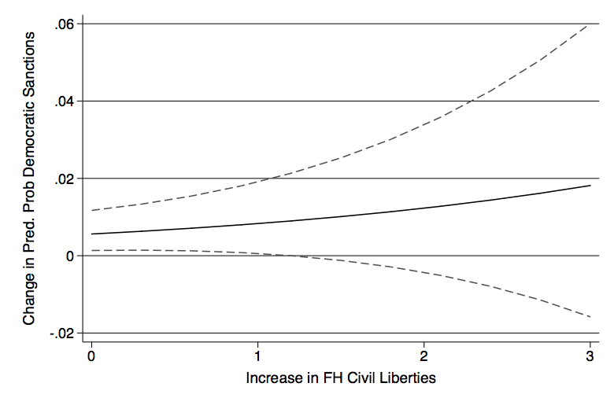
Postestimation is calculated for a country without coups or controversial elections and with ten prior years without sanctions. Increased FH scores indicate less civil liberties. Outer boundaries show 90% confidence interval.

Figure A2. Predicted probability of democratic sanctions after coups depending on change in democracy score

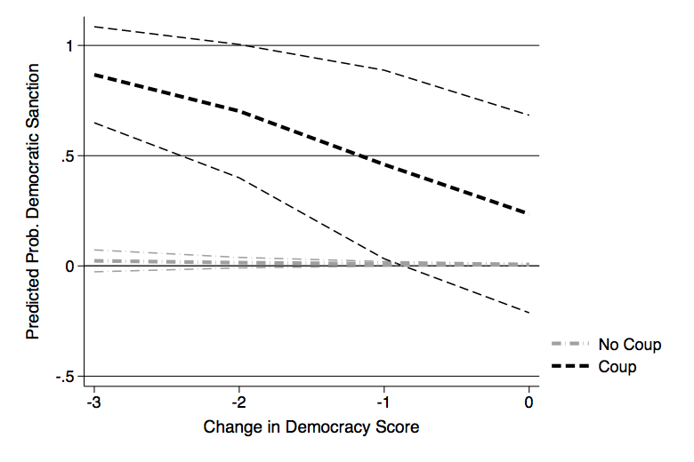
Postestimation is calculated for a country without controversial elections and with ten prior years without sanctions.

Table A1. Multicollinearity statistics
 | Model 1 | Model 5
 | VIF | VIF
Level of democracy | 3.32 | _
Non-democratic sanction t-1 | 1.17 | 1.18
Controversial election | 1.08 | 1.22
Decrease in civil liberties | 1.03 | _
Coup | 1.03 | 1.04
Western trade (log) | _ | 21.71†
Political closeness t-1 | _ | 19.17††
Western organizational ties t-1 | _ | 18.48†††
GDP/capita (thousands USD) t-1 | _ | 2.10
Oil production t-1 | _ | 1.52
Black knight organizational ties t-1 | _ | 1.51
Protests | _ | 1.28
GDP growth t-1 | _ | 1.25
FDI t-1 | _ | 1.13
GDP inflation t-1 | - | 1.10

† VIF=8.66 if excluding GDP per capita, Western organization ties, oil production and political closeness. Coefficient becomes more negative, but remains insignificant.
††VIF=8.92 if excluding polynomials, Black knight organizational ties t-1 and Western organization ties. Coefficient becomes more negative and is still significant at the 99%-level.
†††VIF=10.40 if excluding Western trade (log) and oil production. Coefficient becomes less positive, but is still significant at the 95%-level.

Table A2. Geographical distance
 | HTW  (EU sanctions) | HTW  (US sanctions)
 | (8) | (9)
Coup | 3.820**  (.743) | 4.813**  (.000)
Controversial election | 2.866**  (.491) | 2.279**  (.506)
Decrease in civil liberties | .381  (.384) | .248  (.467)
Level of democracy (0-10) | -.119  (.084) | -.164  (.111)
Non-democratic sanction (lagged) | .104  (.805) | -.658  (.999)
Distance from Brussels | .000**  (.000) | _
Distance from Washington | _ | -.000  (.000)
Constant | -3.139*  (1.065) | .009  (1.264)
Country-years | 1648 | 1582
Countries | 121 | 118
Log pseudo likelihood | -101.962 | -82.101
Pseudo R2 | .301 | .361
** p<.01 *p<.05 †p<.1
Entries are logistic coefficients; robust standard errors clustered by country are given within parentheses. All models include cubic polynomials (not presented in table).

Table A3. Regional dummies
 | HTW  (EU sanctions) | HTW  (US sanctions)
 | (10) | (11)
Coup | 3.484**  (.751) | 5.057**  (.757)
Controversial election | 3.233**  (.525) | 2.135**  (.643)
Decrease in civil liberties | .547  (.434) | .316  (.501)
Level of democracy (0-10) | -.155  (.102) | -.465  (.126)
Non-democratic sanction (lagged) | .250  (.854) | -.303  (.984)
Asia | -1.372  (.905) | -.621  (.785)
Pacific | 1.282  (.746) | 1.718*  (.738)
Latin America | .176  (.629) | 2.841**  (.743)
Middle East | -1.507*  (.687) | _
Constant | -1.451*  (.852) | -.322  (.880)
Country-years | 1668 | 1269
Countries | 123 | 102
Log pseudo likelihood | -94.228 | -75.096
Pseudo R2 | .356 | .408
** p<.01 *p<.05 †p<.1
Entries are logistic coefficients; robust standard errors clustered by country are given within parentheses. All models include cubic polynomials (not presented in table). Africa used as reference category, the Middle East is excluded in the US model as there are no US sanctions against countries located in the Middle East.

Table A4. Robustness test with BTI
HTW
(Western sanctions)
 | (12)
Coup | 4.855**  (.897)
Controversial election | 2.966**  (.465)
Non-democratic sanction t-1 | .580  (.582)
Protests | .106  (.058)
GDP growth t-1 | -.028  (.028)
GDP inflation t-1 | .000**  (.000)
GDP/capita (thousands USD) t-1 | -.152†  (.088)
Western organizational ties t-1 | .294**  (.112)
Black knight organizational ties t-1 | -.059  (.165)
Political closeness t-1 | -3.676*  (1.695)
Western trade (log) | -.027  (.179)
Oil production t-1 | .003  (.008)
EU/US BITs | -.801*  (.407)
Constant | -1.604  (1.675)
Country-years | 1219
Countries | 104
Log pseudo likelihood | -93.899
Pseudo R2 | .436
** p<.01 *p<.05 †p<.1
Entries are logistic coefficients; robust standard errors clustered by country are given within parentheses. All models include cubic polynomials (not presented in table). The Model is a replication of Model 5, keeping the sample constant.
Data and coding for sanctions dataset
Data was obtained from the websites of the US Treasury, Office of Foreign Assets Control, US State Department, Directorate of Defense Trade Controls, and the European Commission, external relations departments. These data were complemented by the Hufbauer et al. dataset (2007) and Morgan et al. dataset (Morgan, Bapat & Krustev, 2009, Morgan, Bapat & Kobayashi, 2014). Further major bibliographic sources were Charron (2011), Crawford (2001), Portela (2010), Reynolds & Wan (2012) and Taylor (2010) as well as media reports (see also codebook; Portela & von Soest, 2012). The coding of sanction episodes was done according to the coding rules laid out in the codebook (Portela & von Soest, 2012) with specific focus on the differentiation of sanction goals and the fine-grained assessment of democratic sanction demands. In that, the categorization is similar but at times deviates from the two other data sets, particularly the Morgan, Bapat & Krustev (2009) dataset. Based on the laid out rules, coding was done for all sanction episodes by three coders; which was followed by a final round of adjustment in cases where coders disagreed (ca. 20% of cases).

References
Charron, Andreas (2011) UN Sanctions and Conflict: Responding to Peace and Security Threats. Abingdon: Routledge.
Crawford, Gordon (2001) Foreign Aid and Political Reform: A Comparative Analysis of Democracy Assistance and Political Conditionality. Basingstoke: Palgrave Macmillan.
Hufbauer, Gary C; Jeffrey J Schott; Kimberley A Elliott & Barbara Oegg (2007) Economic Sanctions Reconsidered. 3rd ed. Washington, DC: Peterson Institute of International Economics.
Morgan, T Clifton; Navin Bapat & Yoshiharu Kobayashi (2014) Threat and imposition of economic sanctions 1945–2005: Updating the TIES dataset. Conflict Management and Peace Science (online first).
Morgan, T Clifton; Navin Bapat & Valentin Krustev (2009) The threat and imposition of economic sanctions, 1971—2000. Conflict Management and Peace Science 26(1): 92–110.
Portela, Clara (2010) European Union Sanctions and Foreign Policy: When and Why Do They Work? London: Routledge.
Portela, Clara & Christian von Soest (2012) GIGA Sanctions Dataset Codebook. Version 18 June 2012. Hamburg: GIGA German Institute of Global and Area Studies (http://www.giga-hamburg.de/en/team/soest).
Reynolds, Cecilia L & Wilfred T Wan (2012) Empirical trends in sanctions and positive inducements in nonproliferation. In: Etel Solingen (ed) Sanctions, Statecraft, and Nuclear Proliferation. New York, NY: Cambridge University Press: 56–122.
Taylor, Brandon (2010) Sanctions as Grand Strategy. Abingdon/London: Routledge & International Institute for Strategic Studies.

